PROJECT REPORT — TO-DO LIST (CLI + GUI)

Project Title: TO-DO List
Internship: DecodeLabs Internship Program
Submitted By: _Hiba Rani

Course: Internship

Submitted To: DecodeLabs

Submission Date: 15-4-2026

Title: Student Task Management System using Python (CLI & GUI)

1. Introduction
This project is a task management system designed for students to manage daily activities such as assignments, lectures, and projects. It is implemented in both CLI and GUI using Python.

2. Objectives
- To manage tasks efficiently
- To use list and dictionary as data structures
- To develop both CLI and GUI applications

3. Technologies Used
- Python
- CLI
- Tkinter

4. Features
- Add task
- View tasks
- Remove task
- Mark task as done
- Search task
- GUI interface for better usability

5. Data Structure Used
- List → stores all tasks
- Dictionary → represents each task
  - id
  - title
  - status

6. Methodology (IPO Model)

Input:
- User enters task details

Process:
- Task stored in list
- Updated based on user actions

Output:
- Displays task list with status

7. GUI Description
- Input field for adding tasks
- Buttons for actions (Add, Delete, Done)
- Listbox to display tasks

8. Code Explanation
- Functions used for modular design
- Loop used for continuous operation
- Tkinter used for GUI components

9. Output (CLI)

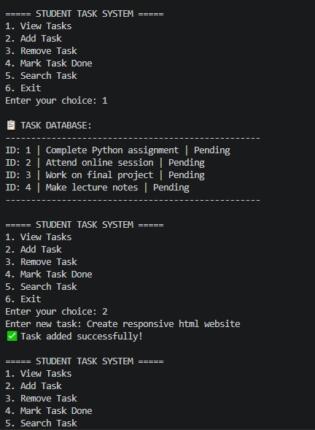

GUI

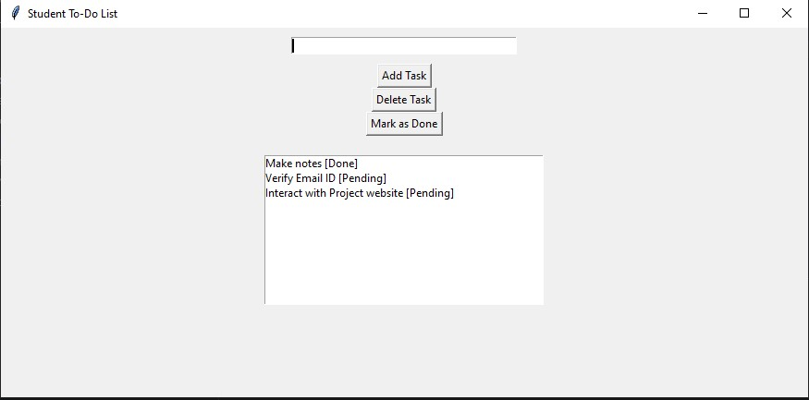

10. Conclusion
This project demonstrates both backend logic and frontend interface development in Python.

